**Kenai Peninsula Chapter of Trout Unlimited Embrace-a-Stream Project: Expanding Knowledge of Fish Habitat in Alaska’s Kenai Peninsula**

*Benjamin Meyer, Kenai Watershed Forum (*[*ben@kenaiwatershed.org*](mailto:ben@kenaiwatershed.org)*)*

*This draft document is best accessed online at* [*https://bookdown.org/kwfwqx/tu_awc_expansion/*](https://bookdown.org/kwfwqx/tu_awc_expansion/)

*2022-03-01*

**Chapter 1 Introduction**

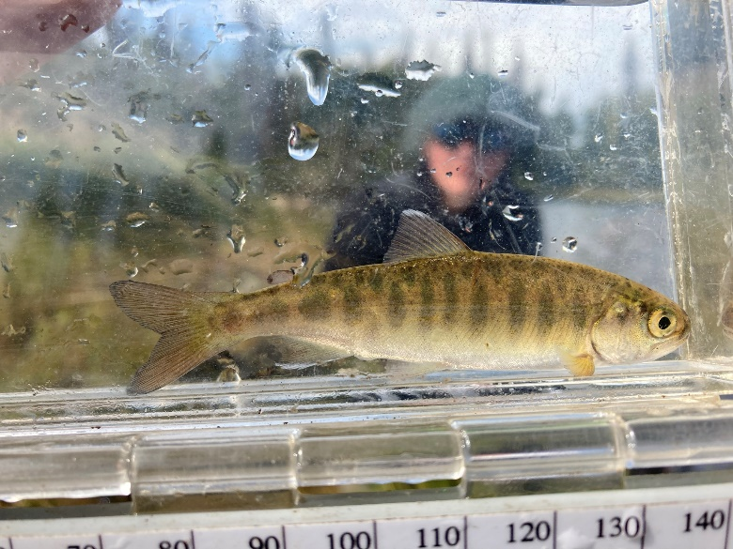

Figure 1.1: Juvenile Coho Salmon

**1.1 Synopsis**

The Kenai Peninsula’s watersheds are significant producers of Pacific salmon. Critical to Alaska’s economic and cultural wellbeing, these salmon support fisheries both inland and throughout Cook Inlet. [The Kenai Peninsula Chapter of Trout Unlimited](https://kenaipeninsula.tu.org/)[1] (KPTU) in collaboration with [Kenai Watershed Forum](https://kenaiwatershed.org/)[2] (KWF) are documenting habitat for salmonid spawning, rearing, and migration in order to increase the known water bodies recognized in the Alaska Department of Fish and Game’s (ADF&G’s) Anadromous Waters Catalog (AWC). The AWC is Alaska’s most powerful tool for regulating, protecting, and conserving anadromous fish habitat. Project funding is secured from Trout Unlimited’s [Embrace-a-Stream](https://www.embraceastream.org/)[3] program. This document contains preliminary data and analysis related to the project.

**1.2 Introduction**

Salmon are intrinsic to the cultural and economic well being of Alaska, but cannot persist on the landscape without healthy habitat. Through strategic conservation efforts, riparian and instream habitat can continue to maintain salmon populations as well as transport marine-derived nutrients; maintain hydrology; and provide refuge during a rapidly changing climate. In recognition of the importance of protecting anadromous fish habitat, the State of Alaska enacted Alaska Statute 16.05.871[4], Protection of Fish and Game, which requires the state to list rivers, lakes, and streams important for the spawning, rearing, or migration of anadromous fish, while also requiring the prior approval of construction or use of said waterbody that may result in adverse effects on salmon populations. In response, ADF&G began overseeing the AWC whose data is now publicly hosted online for resource managers and interested members of the public to utilize. See Figure [1.2](https://bookdown.org/kwfwqx/tu_awc_expansion/index.html#fig:awc-map) for ADFG’s online interactive map these data. Access the map at <https://bit.ly/awc_map>.

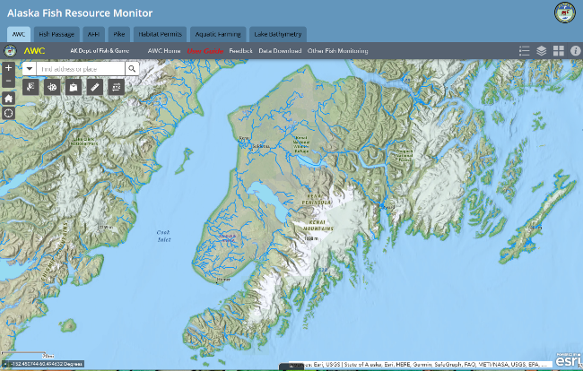

Figure 1.2: Online interactive map of Alaska Department of Fish and Game’s Anadromous Waters Catalog.

Each year, ADF&G solicits anadromous stream nominations from statewide efforts from the previous year. Once accepted, these nominations are incorporated into the AWC and its associated atlas. To date, [the AWC includes nearly 20,000 anadromous streams, rivers, and lakes](https://www.adfg.alaska.gov/sf/SARR/AWC/index.cfm?ADFG=main.home)[5], though it is widely understood that this number represents [less than fifty percent](https://www.adfg.alaska.gov/sf/SARR/AWC/index.cfm?ADFG=nomSubmit.about) of anadromous waterbodies throughout the state[6]. While ADF&G is conducting efforts to update existing data and survey for previously undocumented habitat, there remains a vast number of water bodies in need of surveying and habitat use observations.

In response, Kenai Peninsula Chapter of Trout Unlimited proposed to collect new observations of fish habitat and submit them for inclusion in the AWC. With project funding secured from Trout Unlimited’s [Embrace-a-Stream](https://www.embraceastream.org/) program KPTU established formal collaboration with local non-profit [Kenai Watershed Forum](https://kenaiwatershed.org/), which has been conducting annual fish trapping events since 2005, to provide assistance with project training and logistics.

KWF is working with KPTU to strategically prioritize survey sites to collect fish and habitat data for AWC nomination submissions. Site prioritization is based on criteria including the increase in protected anadromous fish habitat and alignment of trapping priorities with local agency and partnership goals. These are described in greater detail in the methods section. KWF will coordinate with local agency partners to ensure that trapping isn’t replicated in the same areas throughout each summer.

**1.3 Volunteer Training**

On June 5, 2021 a half-day training workshop was conducted by Kenai Watershed Forum staff for fifteen Trout Unlimited volunteers, including but not limited to identifying ideal anadromous fish habitat; responsible deployment and retrieval of minnow traps; juvenile and adult fish identification; data collection and recording while in the field; and safe travel in bear country. Participants were introduced to an [Anadromous Habitat Survey Standard Operating Procedure](https://bit.ly/kwf_awc_sop) (SOP) document[7].

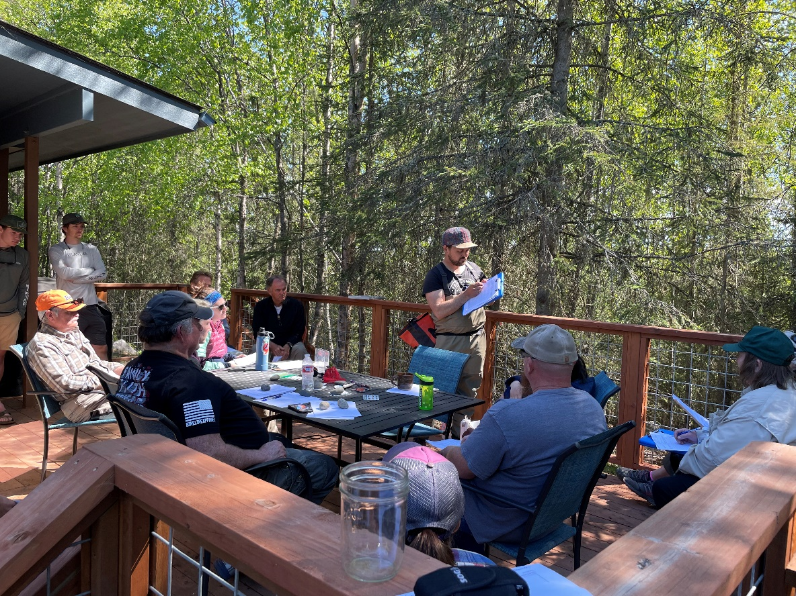

Figure 1.3: Kenai Peninsula Chapter of Trout Unlimited Volunteers.

**1.4 Objectives**

* Submit nominations to increase anadromous stream, river, lake, and wetland coverage in the AWC and corresponding atlas
* Revise or corroborate outdated AWC and atlas data, particularly on Kenai River tributaries experiencing increases in zinc concentrations as well as priority corridors identified by the Kenai Mountains to Sea partnership

# Chapter 2 Methods

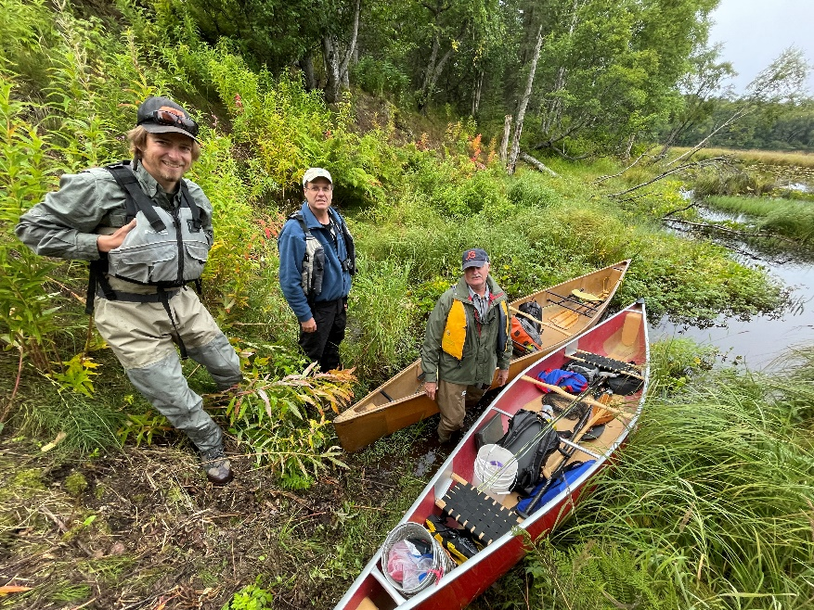

Figure 2.1: Kenai Peninsula Trout Unlimited volunteers preparing for fieldwork at Suneva Lake in August 2021.

## 2.1 Site selection

Fish habitat survey sites are identified using databases generated by Kenai Peninsula Trout Unlimited and Kenai Watershed Forum. Sites further prioritized using the following criteria:

* Significant increase in protection of anadromous fish habitat through addition of new stream miles/lake acreage
* Ability to provide significant revision and/or data corroboration for outdated catalog data
* Ease of accessibility via foot travel based on travel time and ability to obtain private property access
* Proportion of stream or lake adjacent to developed parcels
* Habitat with medium-high risk assessment rating using the [Kenai Peninsula Fish Habitat Partnership’s “Freshwater Potential Threats Ranking Table](https://www.kenaifishpartnership.org/wp-content/uploads/2013/06/DRAFT-Freshwater-CAP_2014_solicitation.pdf)“[8]
* Alignment with trapping priorities of local resource managers as well as partnership efforts including those of Kenai Mountains to Sea (a prioritized corridor list can be found at <https://kenaiwatershed.org/science-inaction/mountains-to-sea/>) and Kenai Peninsula Fish Habitat Partnership (KPFHP)

The project study map may be accessed by following the link at [ArcGIS Online](https://kwf.maps.arcgis.com/apps/webappviewer/index.html?id=ef6e57e2b94c424780b71decf08d50da&extent=-16891358.3246%2C8496162.7219%2C-16658378.2624%2C8619532.0855%2C102100)[9] or in the interactive figure below. Click on the symbols in the upper right hand corner to see the legend and layers list. Toggle layers on/off as needed.

Prior to minnow trap deployment, we obtained all necessary permits from ADF&G including the Aquatic Resource Permit (ARP). As required by the ARP, the ADF&G local Area Management Biologist was notified of trapping locations and timeframes before going into the field. We also obtained landowner permission for access to sites where applicable. Finally, trapping efforts for each day were strategically chosen based on proximity of sites so as to reduce drive and personnel time.

## 2.2 Fish capture and processing

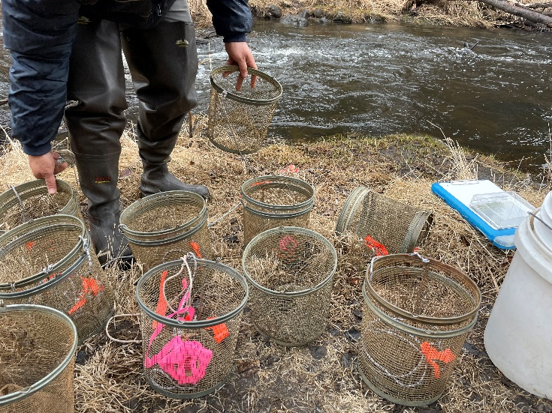

Figure 2.2: Minnow traps being prepared at by Trout Unlimited volunteers at a training workshop at Soldotna Creek in June 2021

### 2.2.1 Minnow Trapping

We used Gee minnow traps (Figure [2.2](https://bookdown.org/kwfwqx/tu_awc_expansion/methods.html#fig:minnow-traps)) baited with salmon eggs as the primary capture methods for juvenile salmonids. We used commercial salmon eggs as bait and placed them in perforated 2-4 oz containers in order to prevent egg consumption by fish. We labeled traps with KWF contact information using brightly colored flagging tape. At the trapping location, we collected site photos and recorded the following on a datasheet: field technician initials, GPS coordinates of trap deployment site(s), and site drawings with pertinent notes regarding fish habitat. We used a minimum of one baited minnow trap, fully submerged in a discrete location, and properly secured to ensure retrieval. We recorded the date and time of deployment. While not exceeding 24 hours, we allowed traps to soak overnight when feasible. Upon trap retrieval, we recorded the date and time and transferred the trap’s contents into a bucket of water.

### 2.2.2 Angling

We conducted angling to survey for anadromous fish in habitats such as lakes or large streams and rivers. We employed both traditional spinning rods and fly-fishing techniques. We recorded start and stop time and quantity of anglers.

### 2.2.3 Fish processing

We identified each fish that we captured to lowest feasible taxa and life stage. We recorded disposition; and in most cases recorded fork length to the nearest millimeter along with photos of identifying features. When completed, we placed fish in a recovery bucket. Once all fish recuperated successfully, we released them near the original capture location. We monitored data throughout the summer for unintended mortalities, and were prepared to cease sampling and contact the area management biologist should >10% unintended collection mortality occur. We entered all data into the Aquatic Resource Permit spreadsheet provided by the ADF&G and will submit it with a written report to ADF&G at the conclusion of each permit year.

These data will be utilized to submit nominations for the inclusion of new miles or acres of fish habitat to the AWC as well as revision or corroboration of fish presence.

## 2.3 Habitat connectivity

In some cases where maps indicated a strong likelihood of anadromous habitat yet we did not capture salmonids, we visited additional sites within the drainage where potential barriers to fish passage may exist such as road crossings or modified lake outlets. We photographed and recorded coordinates at these locations if potential fish barriers were apparent and submitted them to ADF&G for potential inclusion in their [Fish Passage database](https://www.adfg.alaska.gov/index.cfm?adfg=fishpassage.database).

## 2.4 Data management and analysis

### 2.4.1 Data management

We recorded data in the field using pre-printed Rite-in-the-Rain field forms, and entered data into a [Google Sheets database](https://bit.ly/eas_data)[10]. We read data into RStudio and generated this report using the bookdown package (v 0.24). Project edits are managed through a dedicated [project GitHub repository](https://github.com/Kenai-Watershed-Forum/tu_awc_expansion)[11].

All project documents and data can be accessed in a dedicated [Google Drive folder](https://bit.ly/tu_kwf_embrace_a_stream_2021)[12].

### 2.4.2 Analysis

We generated summary tables displaying the quantity of fish captured at each sample site by date. We also generated a csv file reformatting all fish capture data to prepare for submission to the Alaska Department of Fish and Game to fulfill Aquatic Resource Permit requirements.

**Chapter 3 Results**

*Note: All fishing effort and capture results are current as of 2022-03-01.*

**3.1 Fish capture**

Since initiation of fieldwork in summer 2021:

* Over course of 3 fieldwork days in summer 2021, KPTU in collaboration with KWF have conducted a total of 6 sampling events at 6 unique sites, including the training event. See the interactive project map in the Methods section (“[Site selection](https://bookdown.org/kwfwqx/tu_awc_expansion/results.html##%20Site%20selection)”) for a current map of where and when sampling events have occurred.
* Table [3.1](https://bookdown.org/kwfwqx/tu_awc_expansion/results.html#tab:site-visits) summarizes total sampling events by individual site. We typically sampled a site only one time each in summer 2021.
* We have captured 222 fish comprised of 6 unique species. Table [3.2](https://bookdown.org/kwfwqx/tu_awc_expansion/results.html#tab:ct) summarizes current fish capture count by species.
* Table [3.3](https://bookdown.org/kwfwqx/tu_awc_expansion/results.html#tab:site-spp-ct) summarizes total fish capture for each species by site.

| Table 3.1: Total site visits | |
| --- | --- |
| **site** | **n** |
| Lower Soldotna Creek | 2 |
| North Nikiski Lake 1.1 | 1 |
| North Nikiski Lake 1.2 | 1 |
| North Nikiski Lake 2 | 1 |
| Suneva Lake | 1 |
| Upper Ohmer Lake | 1 |

| Table 3.2: Total fish capture count by species | |
| --- | --- |
| **species** | **n** |
| coho salmon | 32 |
| Dolly Varden | 2 |
| rainbow trout | 27 |
| slimy sculpin | 94 |
| stickleback-unspecified | 18 |
| threespine stickleback | 49 |

| Table 3.3: Total fish capture count by species at each site. | | | | | | |
| --- | --- | --- | --- | --- | --- | --- |
| **site** | **coho salmon** | **Dolly Varden** | **rainbow trout** | **slimy sculpin** | **stickleback-unspecified** | **threespine stickleback** |
| Lower Soldotna Creek | 28 | 0 | 22 | 74 | 0 | 0 |
| North Nikiski Lake 1.1 | 2 | 0 | 1 | 9 | 0 | 0 |
| North Nikiski Lake 1.2 | 2 | 0 | 0 | 9 | 0 | 49 |
| Upper Ohmer Lake | 0 | 2 | 4 | 0 | 0 | 0 |
| North Nikiski Lake 2 | 0 | 0 | 0 | 2 | 8 | 0 |
| Suneva Lake | 0 | 0 | 0 | 0 | 10 | 0 |

**3.2 Aquatic Resource Permit and AWC Nominations**

2021 fish capture data was reformatted in to a csv file for submission to ADF&G in fulfillment of the required Aquatic Resource Permit[13]; available in the online in this project’s GitHub repo[14]. These data will be also be shared with the local Area Biologist at the Kenai River Center to determine the best strategy for submitting nomination data in January 2022.

The total number of stream miles / lake acres of successfully nominated to the AWC will be posted here when available in January 2022.

# Chapter 4 Discussion

## 4.1 2021 Fieldwork Summary

### 4.1.1 Anadromous habitat surveys

In summer 2021 we surveyed sites primarily in the region North of Kenai/Soldotna within an hour’s walking distance of the road system.

Survey site selections were made primarily by visually assessing the overlaid map layers of the Anadromous Waters Catalog with the [USGS National Hydrography Database](https://www.usgs.gov/core-science-systems/ngp/national-hydrography) (NHD)[15]. In areas where previously documented anadromous stream or lake extents ended yet connected water bodies continued upstream, we targeted sites suitable for minnow trapping and/or hook and line survey.

At sites surveyed, we captured primarily non-anadromous species such as stickleback and sculpin. We also captured some resident salmonid species such as Dolly Varden and Rainbow Trout.

These results support several conclusions that will direct future fieldwork efforts into summer 2022:

* A need exists to refine methods for survey site selection. Relying on visual assessment of overlay between documented AWC habitat and the NHD map may be insufficient as a prospecting guide for yet-unidentified anadromous waters. Early discussions in Fall 2021 with personnel at ADF&G’s Habitat Division in Anchorage have yielded valuable insight and potential for collaboration. KWF will work with ADF&G in winter 2021/2022 to further refine fieldwork site selection.
* Some drainages in the North Kenai/Nikiski area that may have been historically anadromous have man-made barriers to fish passage that we identified in Summer 2021. One such example was previously undocumented as was discovered by TU volunteers, discussed further in the section below, [Highlight: Habitat Connectivity](https://bookdown.org/kwfwqx/tu_awc_expansion/discussion.html####%20Highlight:%20Habitat%20Connectivity). Identifying fish passage barrier sites is a critical first step in determining if restoration is feasible.

#### 4.1.1.1 Highlight: Habitat Connectivity

In one case where map interpretation suggested presence of salmonids but we captured none, we visited other locations in the watershed where fish barriers may be present. We found evidence of man-made fish barriers:

* Suneva Lake - Suneva Lake lies to the North of Daniels Lake in the Nikiski area. The lake’s surface area is appx 1.0 sq km, and flows directly in to Cook Inlet 0.61 km downstream from the lake outlet. Aerial imagery indicates that littoral is ~95% undeveloped. Littoral parcels are primarily privately owned.

We conducted extensive sampling on Suneva lake, using minnow traps as well as angling. We captured stickleback and sculpin, but no salmonids despite extensive effort.

We visited the outlet at Suneva lake and discovered two perched culverts installed where the outlet stream crosses Sockeye Avenue (see figure [4.1](https://bookdown.org/kwfwqx/tu_awc_expansion/discussion.html#fig:suneva-outlet). The culvert is likely impeding fish passage (assuming no additional downstream barriers), as there is a drop of several feet between the stream channel and the culvert outlet.

A site visit to the mouth of the creek flowing from Suneva Lake at its outlet at Cook Inlet will help determine if the waterway has potential to host anadromous species and may be part of future fieldwork.

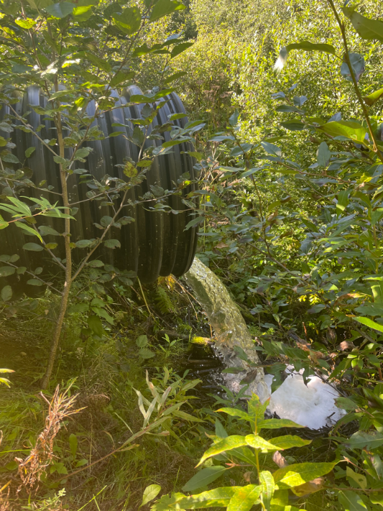

Figure 4.1: Perched culvert near outlet of Suneva Lake, intersection with Sockeye Avenue

# Chapter 5 2022 Fieldwork Plans

## 5.1 2022 Anadromous habitat surveys

Fieldwork described in this report will continue in July - September 2022. A minimum of five additional fieldwork days will be supervised by KWF staff, with specific dates to be determined.

Fieldwork dates will generally be on weekend days, and will be selected based on availability of Trout Unlimited volunteers. KWF will announce proposed fieldwork days in April 2022 and send them to the Kenai Peninsula Trout Unlimited president. If interest is sufficient, KWF will again offer a half-day training workshop for volunteers.

A list of proposed 2022 field survey sites was updated in January 2022 and is maintained in the project online database [Google Sheet](https://docs.google.com/spreadsheets/d/1S0hwY4EQo9Xtz5d4UnSBCbZoJ0ft_HGQrarfmA5dwNY/edit?usp=sharing)[16] (see the tab titled “E_All_Sites”). These sites are visible in the project map as open red circles (see section 2.1 [Site selection](https://bookdown.org/kwfwqx/tu_awc_expansion/methods.html#site-selection))

1. <https://kenaipeninsula.tu.org/>[↩︎](https://bookdown.org/kwfwqx/tu_awc_expansion/index.html#fnref1)
2. <https://www.kenaiwatershed.org>[↩︎](https://bookdown.org/kwfwqx/tu_awc_expansion/index.html#fnref2)
3. <https://www.embraceastream.org/>[↩︎](https://bookdown.org/kwfwqx/tu_awc_expansion/index.html#fnref3)
4. <http://www.adfg.alaska.gov/index.cfm%3Fadfg=habitatregulations.prohibited>[↩︎](https://bookdown.org/kwfwqx/tu_awc_expansion/index.html#fnref4)
5. <https://www.adfg.alaska.gov/sf/SARR/AWC/index.cfm?ADFG=main.home>[↩︎](https://bookdown.org/kwfwqx/tu_awc_expansion/index.html#fnref5)
6. <https://www.adfg.alaska.gov/sf/SARR/AWC/index.cfm?ADFG=nomSubmit.about>[↩︎](https://bookdown.org/kwfwqx/tu_awc_expansion/index.html#fnref6)
7. <https://bit.ly/kwf_awc_sop>[↩︎](https://bookdown.org/kwfwqx/tu_awc_expansion/index.html#fnref7)
8. <https://www.kenaifishpartnership.org/cap/>[↩︎](https://bookdown.org/kwfwqx/tu_awc_expansion/methods.html#fnref8)
9. <https://arcg.is/01mHjP>[↩︎](https://bookdown.org/kwfwqx/tu_awc_expansion/methods.html#fnref9)
10. <https://bit.ly/eas_data>[↩︎](https://bookdown.org/kwfwqx/tu_awc_expansion/methods.html#fnref10)
11. <https://github.com/Kenai-Watershed-Forum/tu_awc_expansion>[↩︎](https://bookdown.org/kwfwqx/tu_awc_expansion/methods.html#fnref11)
12. <https://bit.ly/tu_kwf_embrace_a_stream_2021>[↩︎](https://bookdown.org/kwfwqx/tu_awc_expansion/methods.html#fnref12)
13. <http://www.adfg.alaska.gov/index.cfm?adfg=otherlicense.aquatic_reports>[↩︎](https://bookdown.org/kwfwqx/tu_awc_expansion/results.html#fnref13)
14. <https://github.com/Kenai-Watershed-Forum/tu_awc_expansion/tree/main/output>[↩︎](https://bookdown.org/kwfwqx/tu_awc_expansion/results.html#fnref14)
15. <https://www.usgs.gov/core-science-systems/ngp/national-hydrography>[↩︎](https://bookdown.org/kwfwqx/tu_awc_expansion/discussion.html#fnref15)
16. <https://bit.ly/eas_data>[↩︎](https://bookdown.org/kwfwqx/tu_awc_expansion/methods.html#fnref10)